EXP 1: Transformation between Cartesian, Cylindrical and spherical coordinate system
Transformation of Cartesian coordinate points into Cylindrical and spherical coordinate system
Code :
clc;
x=input('Enter the value of X=');
y=input('Enter the value of y=');
z=input('Enter the value of z=');
r=sqrt(x^2+y^2);
pi=atand(y/x);
disp('Cartesian to cylindrical coordinate system of p(r,pi,z)=',[r pi z]);
r=sqrt(x^2+y^2+z^2);
theta=acosd(z/r);
pi=atand(y/x);
disp('Cartesian to spherical coordinate system of s(r,theta,pi)=',[r theta pi]);
Output;
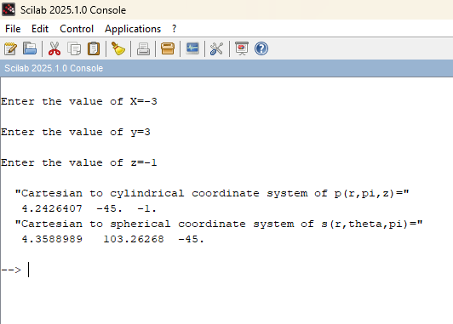

(ii) Transformation of Cylindrical coordinate points into Cartesian and spherical
coordinate system
Code :
clc;
r=input('Enter the value of r=');
pi=input('Enter the value of pi=');
z=input('Enter the value of z=');
x=r*cosd(pi);
y=r*sind(pi);
z=z;
disp('cylindrical to cartesian coordinate system of p(x,y,z)=',[x y z]);
r=sqrt(r^2+z^2);
pi=pi;
theta=acosd(z/r);
disp('cylindrical to spherical coordinate system of s(r,pi,theta)=',[r theta pi]);
Output :
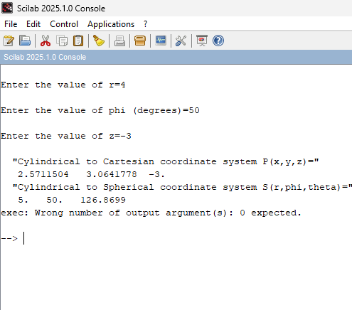

(iii) Transformation of spherical coordinate points into Cylindrical and Cartesian coordinate system
Code:
clc;
clear;
r = input('Enter the value of r = ');
phi = input('Enter the value of phi (degrees) = ');
theta = input('Enter the value of theta (degrees) = ');
x = r*sind(theta)*cosd(phi);
y = r*sind(theta)*sind(phi);
z = r*cosd(theta);
disp('Spherical to Cartesian Coordinates P(x,y,z) = ');
disp([x y z]);
rho = r*sind(theta);
z = r*cosd(theta);
disp('Spherical to Cylindrical Coordinates S(rho,phi,z) = ');
disp([rho phi z]);
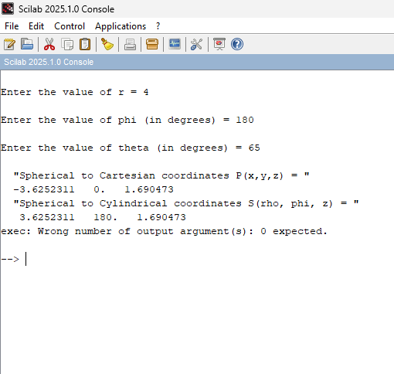
Output:

